**Camera Master Image**

**Setting up master image**

1. Allow robot to pick and place 5 totes from conveyor onto empty pallet with emulator
2. On tote 6 (layer 2), stop the robot over the pallet with tote in gripper. Press step
3. In step STEP mode, continue to step the robot program (place_pallet) thru line 75:
   1. 75:L PR[11:Pallet Place] max_speed FINE Tool_Offset,PR[30:Vision Pic Off] ;
4. Skip down and run line 86-88 in step mode
   1. 87: R[75:Vision X Found]=0 ;
   2. 88: R[76:Vision Y Found]=0 ;
   3. 89: R[77:Vision R Found]=0 ;
5. Skip down and run line 112 in step mode
   1. 112: IF R[4:Tote Position]<4,JMP LBL[4] ;
6. Run to line 140 (186), but stop if it is going to crash into tote below
   1. L PR[11:Pallet Place] max_speed CNT25 Tool_Offset,PR[25:Vision Place O] Offset,PR[18:Place -Z Offset] AP_LD15
7. Center tote on layer 1 directly below tote in robot gripper so that it would place perfectly. Jog Z- slowly in world mode if the tote is not close enough (it should be just above the step) of the tote below it.

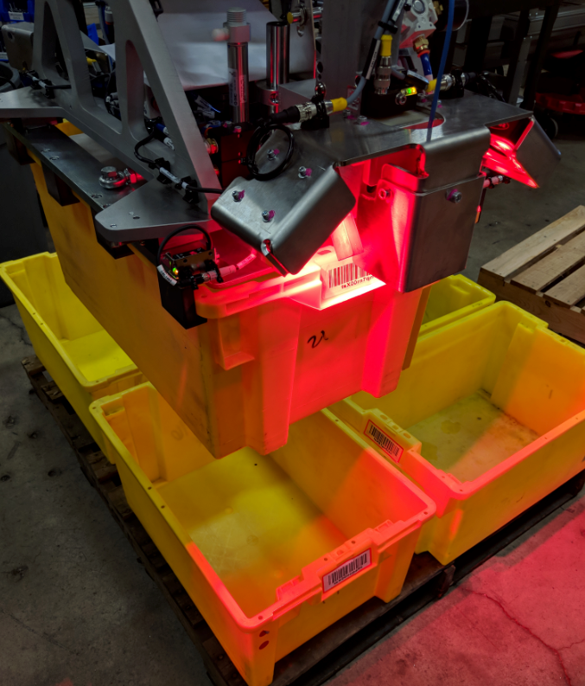

1. After lined up perfectly, run program backwards (BWD instead of FWD button) to the previous point (Line 75)
2. Using Internet Explorer, navigate to the robot at 11.200.1.20
3. Enter “Vision Setup”.
4. If iRVision software has not been installed, do that at this time
   1. Locate red usb stick inside robot controller, insert into usb drive of controller
   2. Connect to the robot via web browser (11.200.1.20)
   3. Click on “Vision Setup” tab
   4. Install when prompted in internet explorer
5. Open the camera program, either SideA_CornerLocation or side B, depending what side of the tote is under the camera:

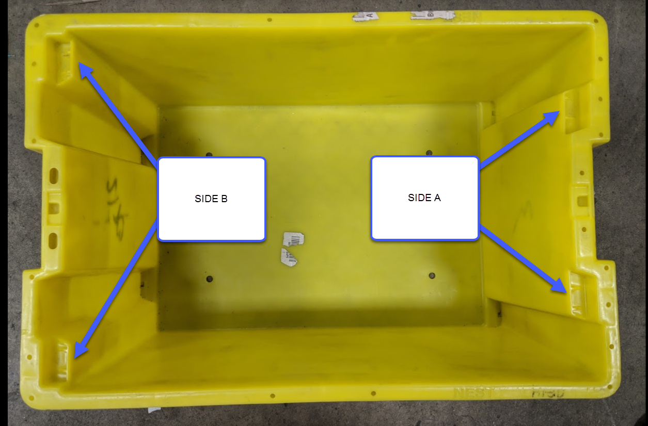

1. Train the camera:
   1. Click “Snap + Find”, green scribe lines should show on the image
   2. Click “Set” to set the reference positions. This is the master offset the camera will use
   3. Click “Save”
   4. Click “End Edit” 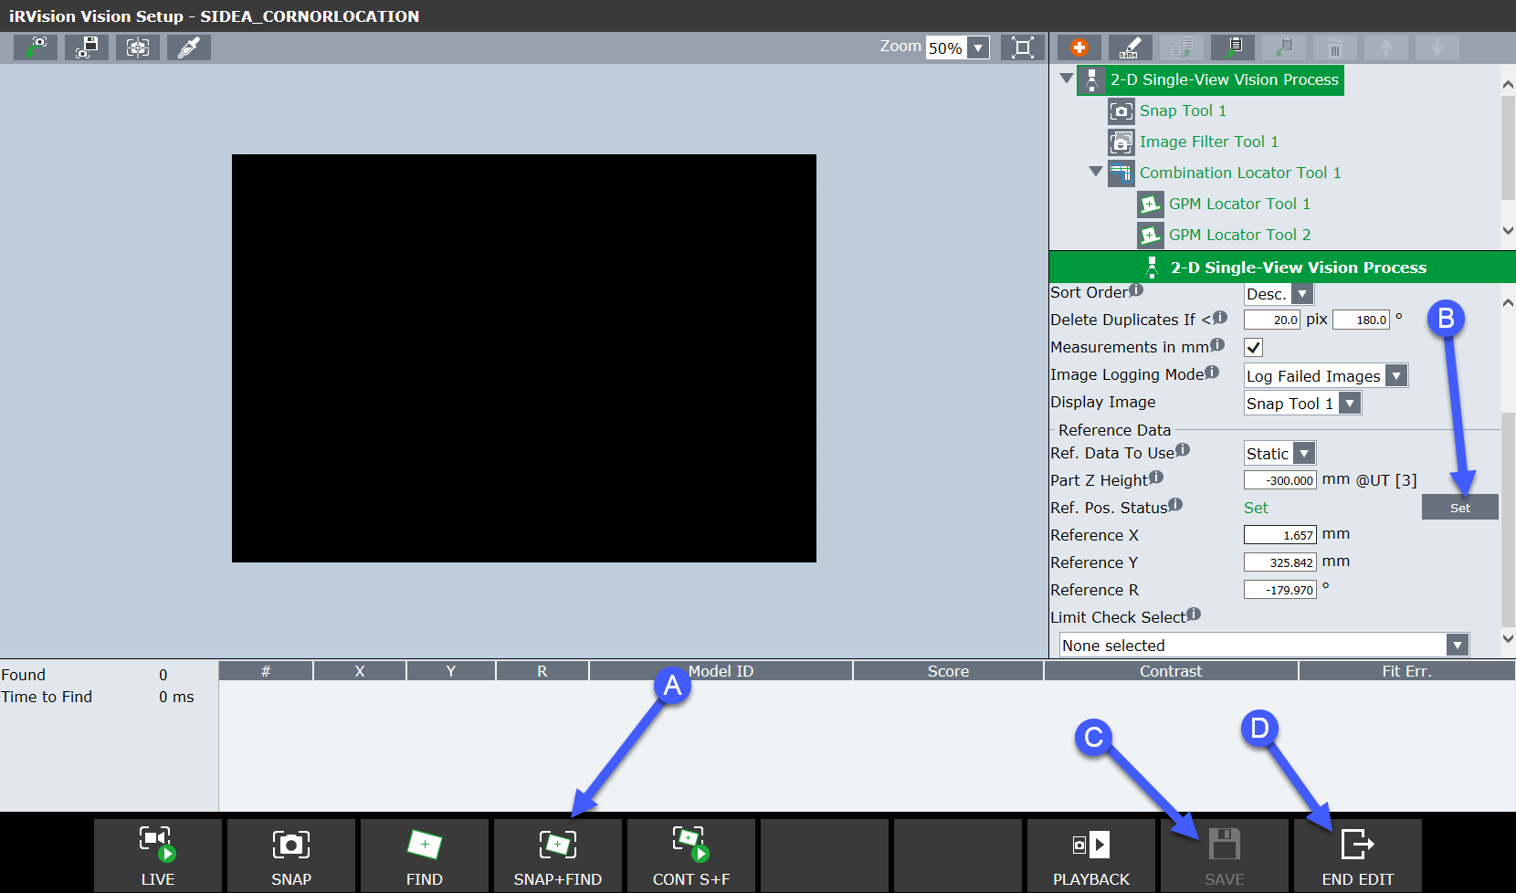
2. ~~Do this same procedure for the SideA_EdgeLocation (or SideB depending on step 12) camera program [If EdgeLocation fails, try using a different tote]~~ we are not doing this anymore
3. Test the results of this by letting the robot continue to pick and place totes to fill up layer 2. There should now be 10 totes on the pallet
4. For the first tote on layer 3, repeat this entire process for the opposite side of the tote
5. Test the results of this by letting the robot continue to pick and place totes to fill up layer 2. There should now be 15 totes on the pallet